THE NILE RIVER

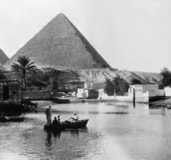
The Nile River is more than 6 700 kilometres long. It begins its journey in the highlands and large lakes of Africa and carries a huge volume of water to the deserts of Egypt. The following points are primarily concerned with the 1 000 kilometres of the Nile which flows through Egypt and which shaped the civilisation of the Ancient Egyptians.
The Nile River provided the Ancient Egyptians with:
- Fertile soils on which to grow their crops of barley, wheat, flax and sesame.
- Abundant plant and animal life such as reeds, papyrus, fish and water fowl.
- An efficient transport and communication system. (The Nile River is navigable 600 kilometres upstream).
- An efficient ally in administering the land since most of the population was confined to its banks – this made protecting Egyptian citizens and collecting taxes easy tasks.
- A means for recreation with fishing, swimming, hunting and boating all being favourite past times for Ancient Egyptians.
- Materials for the building of homes and shelters which for most Ancient Egyptians were generally made from mud and reeds since wood and stone were scarce in Ancient Egypt.
- Materials for the building of their boats which were generally made from reeds.
- Materials with which to write, papyrus was used for making scrolls, pens and ink. Papyrus scrolls had many advantages over the use of clay tablets used by many other early civilizations.
ACTIVITY:
Make a summary of these eight points by completing the following sheet. In each space draw a diagram showing one of the ways in which the Nile helped the Ancient Egyptians. Write a brief explanation underneath each picture
Fertile soils grow crops of barley, wheat and flax.
THE IMPORTANCE
OF
THE NILE RIVER
TO
THE ANCIENT EGYPTIANS
